Module Name: Student Management System
Test Case ID: TC_001
Tester Name: Janvi Patel
Webpage Name: Student Management System
Technology Used: Python
IDE: Visual Studio Code
Browser :Not Applicable

Scenario 1a

Scenario ID: 1a

Scenario: Add Student with Valid Details

Test Steps:

- Open application. .2
- Select Add Student..
- Enter Student ID, Name and Age.

Test Input: ID:

101, Name: Janvi, Age: 21

Expected Result:

Student record should be added successfully.

Actual Result:

Student record added successfully.

Status:

PASS
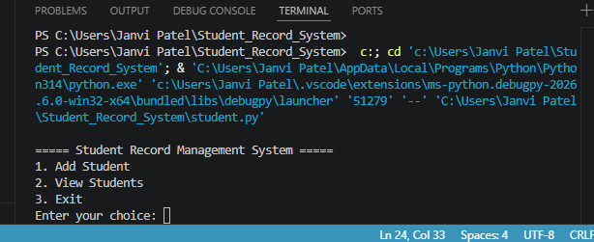

Scenario 1b

Scenario ID: 1b

Scenario: View Student Records

Test Steps:

- Open application.
- Select View Students.

Test Input:

Choice: 2

Expected Result:

Student records should be displayed.

Actual Result:

Student records displayed successfully.

Status:

PASS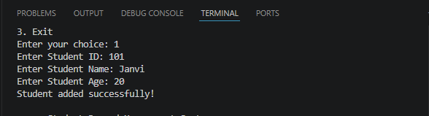

Scenario 1c

Scenario ID: 1c

Scenario: Exit Application

Test Steps:
- Open application.
- Select Exit option.

Test Input:

Choice: 3

Expected Result:

Application should exit successfully.

Actual Result:

Application exited successfully.

Status:

PASS
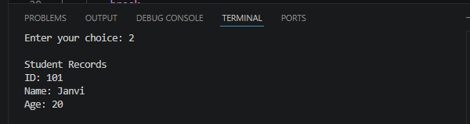

Scenario 1d

Scenario ID: 1d

Scenario: Add Student with Different Valid Details

Test Steps:
- Open application.
- Select Add Student.
- Enter valid student details.

Test Input:

ID: 102, Name: Rahul, Age: 20

Expected Result:

Student record should be added successfully.

Actual Result:

Student record added successfully.

Status: PASS
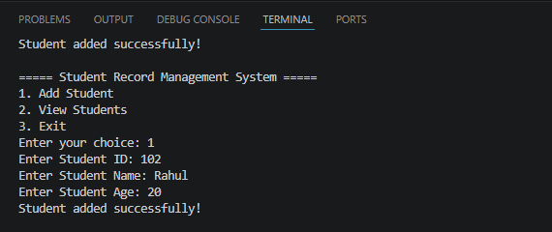

Scenario 1e

Scenario ID: 1e

Scenario: Add Another Student Record

Test Steps:
1.Select Add Student
2. Enter Student ID, Name and Age.
3.Submit the record.

Test Input:

ID: 103, Name: Riya, Age: 20

Expected Result:

New student record should be added successfully.

Actual Result:

New student record added successfully.

Status:

PASS

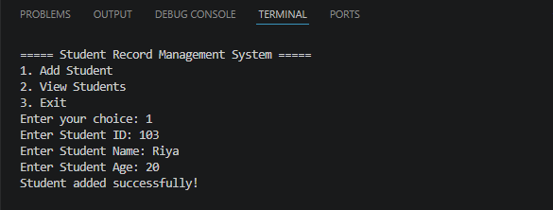

Scenario 1f

Scenario ID: 1f

Scenario: View Student Record After Adding

Test Steps:
- Add a valid student record.
- Select View Students.

Test Input: ID:

104, Name: Neha, Age: 21

Expected Result:

Newly added student should appear in the student records.

Actual Result:

Newly added student appeared in the student records.

Status:

PASS

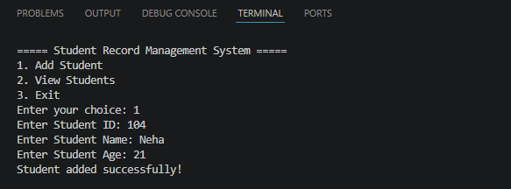

Scenario 1g

Scenario ID: 1g

Scenario: Add Student with Different Age

Test Steps:

1. Select Add Student.
2. Enter Student ID, Name and Age.

Test Input:

ID: 105, Name: Amit, Age: 22

Expected Result:

Student record should be added successfully with the given age.

Actual Result:

Student record added successfully with the given age.

Status:

PASS

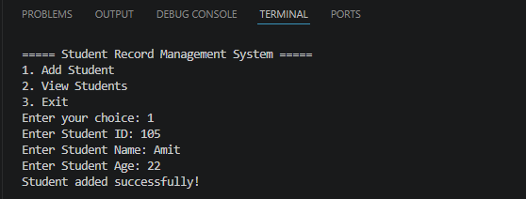

Scenario 1h

Scenario ID: 1h

Scenario: View Multiple Student Records

Test Steps:
- Add student records.
- Select View Students.

Test Input:

Multiple student records

Expected Result:

All available student records should be displayed.

Actual Result:

Student records displayed successfully.

Status:

PASS

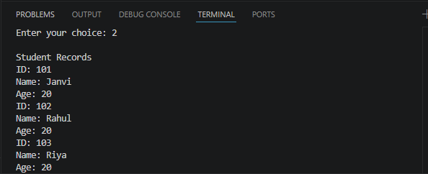

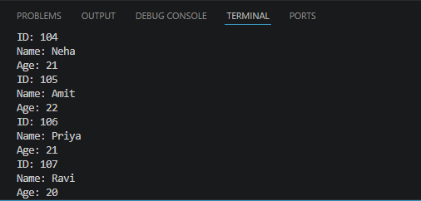

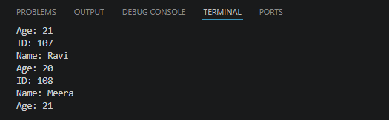

Scenario 1i

Scenario ID: 1i

Scenario: Add Student with Valid ID

Test Steps:
- Select Add Student.
- Enter a valid Student ID, Name and Age.

Test Input:

ID: 106, Name: Priya, Age: 21

Expected Result:

Student record should be stored successfully.

Actual Result:

Student record stored successfully.

Status:

PASS
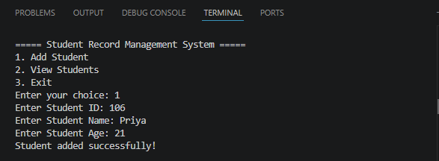

Scenario 1j

Scenario ID: 1j

Scenario: Verify Added Student Record

Test Steps:
- Add a student record.
- Select View Students and verify the record.

Test Input: ID:
107, Name: Ravi, Age: 20

Expected Result:

The entered student details should be displayed correctly.

Actual Result:

Entered student details displayed correctly.

Status:

PASS

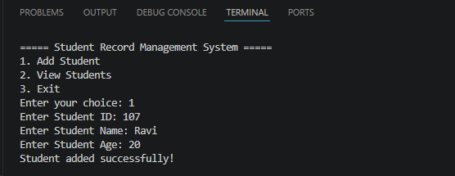

Scenario 1k

Scenario ID: 1k

Scenario: Verify Application Menu

Test Steps:
- Open and run the Student Record Management System.

Test Input:

Application Start

Expected Result:
Application menu should be displayed.

Actual Result:

Application menu displayed successfully.

Status:

PASS

Scenario 1l

Scenario ID: 1l

Scenario: Verify Student Management Flow

Test Steps:
1. Open application.
2. Add a student record.
3.Select View Students.

Test Input:
ID: 108, Name: Meera, Age: 21

Expected Result:

Student should be added and displayed successfully.

Actual Result:

Student was added and displayed successfully.

Status:

PASS
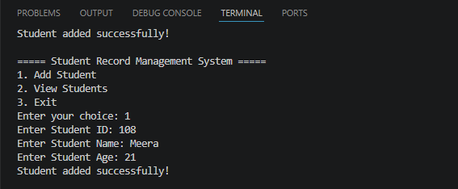

Summary of Test Results

A total of 12 test scenarios (1a to 1l) were executed for the Student Record Management System. The testing covered adding student records, viewing student records, verifying the application menu, exiting the application, and checking the complete student management flow.

All 12 test cases passed successfully.

- Total Test Cases: 12
- Passed: 12
- Failed: 0
- Pass Percentage: 100%
- Overall Status: PASS

- Conclusion and Recommendations

Conclusion

The Student Record Management System was tested successfully using all defined test scenarios. The application correctly performs the basic operations of adding and viewing student records and provides the required application menu and exit functionality.

Since all test cases passed, the system is working as expected for the tested scenarios.

- Recommendations

- Add input validation for Student ID and Age.
- Prevent duplicate Student IDs.
- Display a proper message when no student records are available.
- Add Search, Update, and Delete features for better student record management.
- Store records in a file or database so that data is not lost when the program closes.
- Improve the user interface and error handling.

- Issues Found

During functional testing, no major functional issues were found in the tested scenarios.

All 12 scenarios from 1a to 1l produced the expected results.

- Minor improvements that can be considered:

- Invalid input handling can be improved.
- Student data is currently stored temporarily and may be lost after the program exits.
- Duplicate student IDs can be prevented.

- Bug Reports

Bug Report 1

- Bug ID: BR-001
- Module: Student Record Management
- Issue: No major bug found during testing.
- Expected Result: Application should perform all tested operations correctly.
- Actual Result: All tested operations performed correctly.
- Severity: None
- Priority: None
- Status: Closed / No Bug

- Overall Bug Status:
No critical or major bugs were identified during the execution of test scenarios 1a to 1l. The application achieved a 100% pass rate for the given test cases.

